Burkina Faso

## Political Stability Estimate Data

The data set shows the political stability estimate of the country each year.

## # A tibble: 19 x 5  
## country iso3c date stability stabilityCategory4   
## <chr> <chr> <dbl> <dbl> <chr>   
## 1 Burkina Faso BFA 1996 -0.302 moderately unstable  
## 2 Burkina Faso BFA 1998 -0.111 moderately unstable  
## 3 Burkina Faso BFA 2000 0.0592 moderately stable   
## 4 Burkina Faso BFA 2002 -0.309 moderately unstable  
## 5 Burkina Faso BFA 2003 0.0669 moderately stable   
## 6 Burkina Faso BFA 2004 -0.0823 moderately unstable  
## 7 Burkina Faso BFA 2005 -0.0649 moderately unstable  
## 8 Burkina Faso BFA 2006 0.156 moderately stable   
## 9 Burkina Faso BFA 2007 0.308 moderately stable   
## 10 Burkina Faso BFA 2008 0.120 moderately stable   
## 11 Burkina Faso BFA 2009 0.0349 moderately stable   
## 12 Burkina Faso BFA 2010 -0.118 moderately unstable  
## 13 Burkina Faso BFA 2011 -0.555 moderately unstable  
## 14 Burkina Faso BFA 2012 -0.573 moderately unstable  
## 15 Burkina Faso BFA 2013 -0.763 moderately unstable  
## 16 Burkina Faso BFA 2014 -0.787 moderately unstable  
## 17 Burkina Faso BFA 2015 -0.611 moderately unstable  
## 18 Burkina Faso BFA 2016 -0.867 moderately unstable  
## 19 Burkina Faso BFA 2017 -0.925 moderately unstable

## Political Stability Estimate Plot

The plot shows the trends of stabilization and destabilization for the each country.

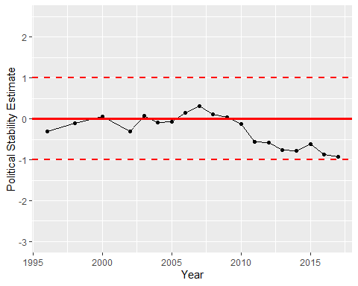

Political Stability Trend